Instructions for returning BioNomadix modules for firmware upgrade
- Provide the model and serial number of the units being returned for firmware upgrade.
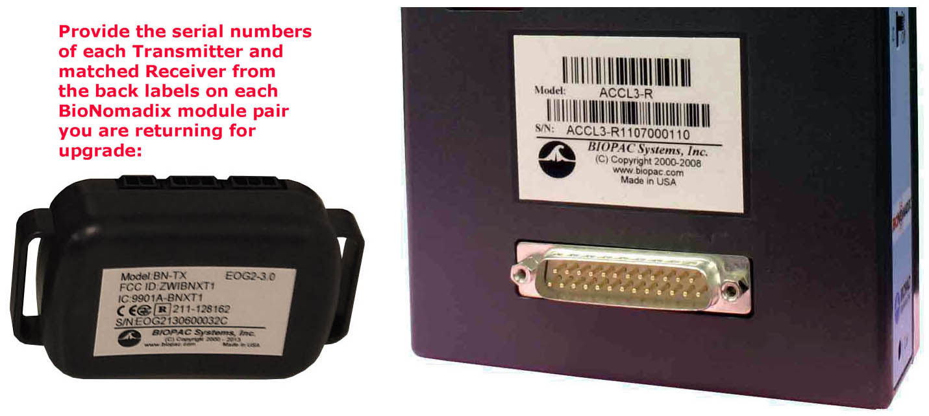
Transmitter S/N: Receiver S/N:
enter serial number here enter serial number here
enter serial number here enter serial number here
enter serial number here enter serial number here
enter serial number here enter serial number here
enter serial number here enter serial number here
enter serial number here enter serial number here
- Send to Support@biopac.com to request a Return Merchandise Authorization (RMA) number.

Do NOT return items without completing the form and receiving an RMA number.

AFTER YOU RECEIVE THE RMA #
BIOPAC Support will provide you with a Return Merchandise Authorization (RMA) number.
When you are ready to return the units:
  - Place a purchase order for the BioNomadix upgrade BN-TX-UPG and as applicable, a BioNomadix Logger BN-LOGGER and or SMART CENTER.BN-SMART-X.
  - Box and return only the BioNomadix Receiver and Transmitter - no straps or chargers. The units must be packaged carefully and returned in a box clearly labeled with the RMA number on the outside:
RMA: 111111-BNX (example only)
BIOPAC Systems, Inc.
42 Aero Camino
Goleta, CA 93117 USA
The upgraded units will be returned with current firmware and will each Transmitter will be ‘paired” to the corresponding Receiver module; upgraded Transmitters will then also be compatible with a BioNomadix Logger
or Smart Center.

